

**Project report**

**Mobile phone shop desk assistant**



**- Arul Manivannan**

( lathanatarajan1972@gmail.com)

**Contents of the report:**

|  |  |  |  |
| --- | --- | --- | --- |
| **1** |  | **INTRODUCTION** | |
|  |  | 1.1 Overview | |
|  |  | 1.2 Purpose | |
| **2** |  | **LITERATURE SURVEY** | |
|  |  | 2.1 Existing problem | | |
|  |  | 2.2 Proposed solution | | |
| **3** |  | **THEORITICAL ANALYSIS** | |
|  |  | 3.1 Block diagram | |
|  |  | 3.2 Hardware / Software designing | | |
| **4** |  | **EXPERIMENTAL INVESTIGATIONS** | | |
| **5** |  | **FLOWCHART** | |
| **6** |  | **RESULT** |
| **7** |  | **ADVANTAGES & DISADVANTAGES** | | |
| **8** |  | **APPLICATIONS** | |
| **9** |  | **CONCLUSION** | |
| **10** |  | **FUTURE SCOPE** | |
| **11** |  | **BIBILOGRAPHY** | |
|  |  | **APPENDIX** | |

**Introduction:**

**Overview:**

The project “Mobile phone shop help desk assistant “ is a application which serves as the information provider and virtual sales representative of the shop. It is built on IBM cloud’s services and tools and its integrated with telegram to provide a smooth user interface.

**Purpose:**

The purpose of the project is to reduce the task of the sales man of answering calls and telling the details about the shop. Instead this application can be used to interact with the shop by the consumers to get all the relevant details they want.

**Literature survey:**

**Existing problems:**

The problems faced by mobile shop owners is that , they have to constantly answer phone calls regarding the details about the shop or any specific mobile phone model. This consumes a lots of time and they are not able to focus on the real time customers present in the shop.

**Proposed solution:**

The solution proposed is an Artificial intelligence powered **chat bot** built primarily using Watson assistant and other IBM features which would be explained in the following sections. The chat bot responds to the user with queries like address , membership details, landmark and other basic information. The main feature of the chat bot is to respond to the specifications of a particular mobile phone model by using the Watson discovery feature.

**Theoretical Analysis:**

**Block diagram:**

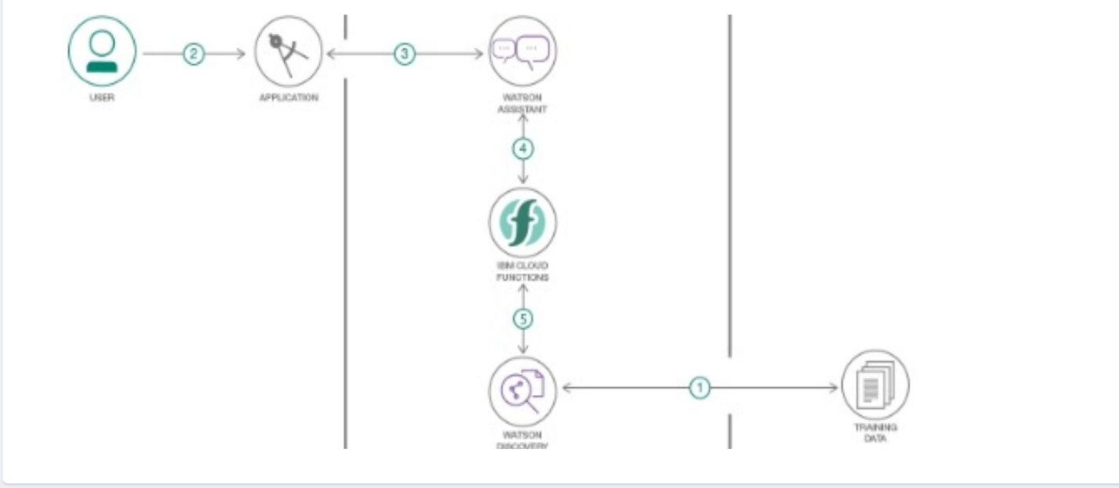

**Hardware/software designing:**

The design of the chat bot involved creating a Watson assistant framework. Next Watson’s Discovery function was also added to give more details about the model of the phone.

Adding Cloud functions to the existing framework to deploy the assistant as a web application was the next step.

Creating a Node-Js framework for connecting the Watson assistant bot to telegram( or any web application )

Creating a Telegram bot using bot father feature.

Used Watsons Smart discovery option to answer the queries in a precise way.

Deployed the application

**Experimental investigations:**

The watson’s discovery feature was quite fascinating. The option to use Smart discovery feature for detecting images or text before hand itself makes it easy for the cloud to answer in a precise way. However The watson’s discovery feature becomes less precise when images are involved in the document .

**Flowchart:**

Deploying the application

Creating a node- Js application framework to connect the assistant to the web application

Creating a new watson Discovery feature and uploading the relevant documents..

Creating a Watson assistant object And defining the features , dialogues etc..

**Result:**

Thus the Chat bot is successfully deployed using Telegram and it correctly answers to all the relevant queries asked by the user.

Advantages:

* This chat bot is a boon for very busy and productive shops as it saves a lot of time .
* Watson’s Discovery feature makes the application more intelligent and interactive.
* Integration with a web application makes the bot more user friendly
* Accessible 24*7
* Low or null maintenance

**Disadvantages:**

* The chat bot needs to be updated constantly with the relevant documents for answering queries.
* Server issues can make the working little nasty.

**Applications:**

The chat bot finds its applications in various fields such as medical pharmacy, Electrical distribution board and various other industries to connect with the consumers and answer to their greviences.

**Conclusions:**

**Thus an Artificial Intelligence powered chat bot is deployed for better customer management of the shop.**

**Future scope:**

The project can be made further made more intelligent by trying to give technical solutions and checking maintenance related issues for the mobile phones of the customers.

**Bibliography:**

The entire study material and references where provided by the SmartBridge team on their platform.

**Projects link:**

<https://t.me/Saibabaarulbot>